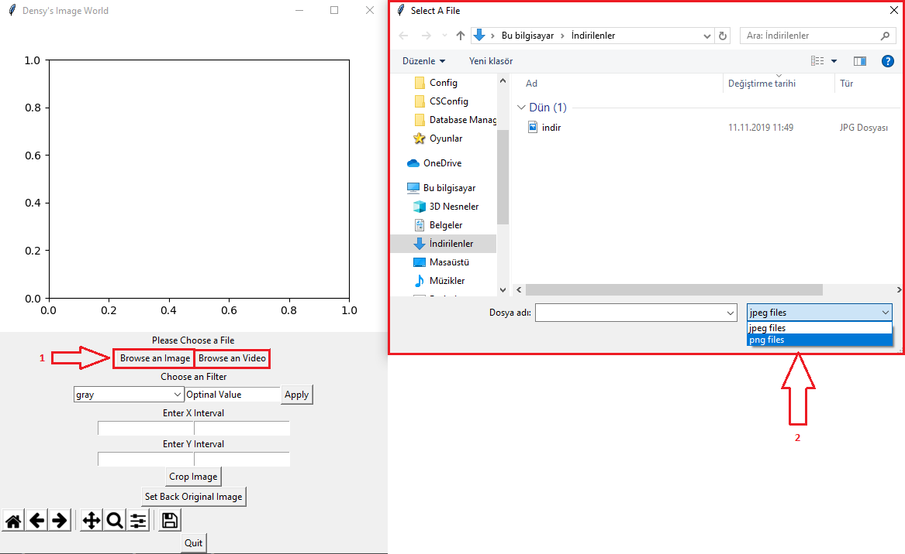

Figure: Browsing and Loading an Image to Image World Application

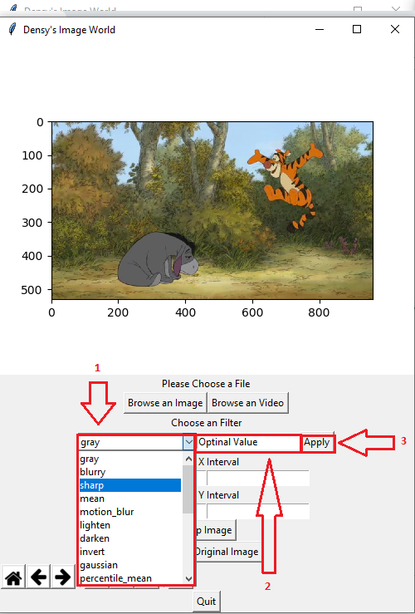

Figure: Selecting a Filter to Apply and Give It Optional Value

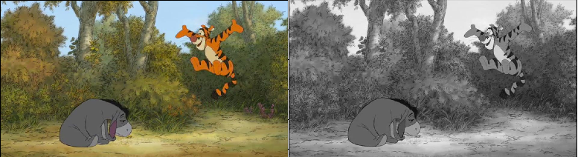

Figure: Original Image and Gray Filtered Result

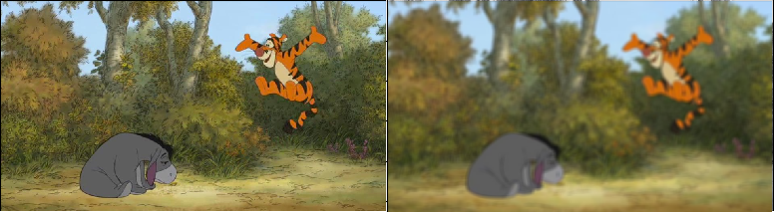

Figure: Original Image and Blur Filter Result

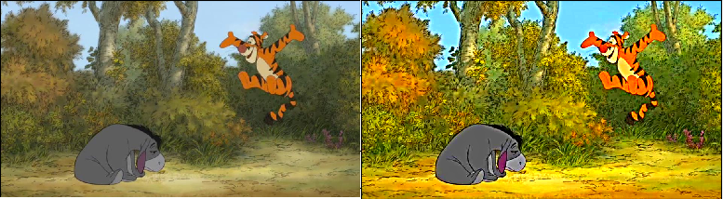

Figure: Original Image and Sharpen Filter Result

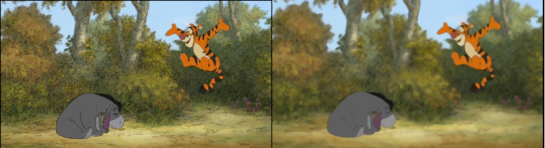

Figure: Original Image and Mean Filter Result

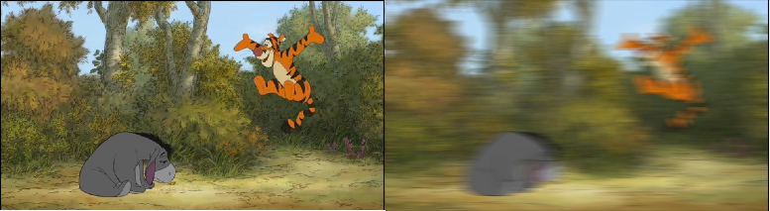

Figure: Original Image and Motion Blur Filter Result

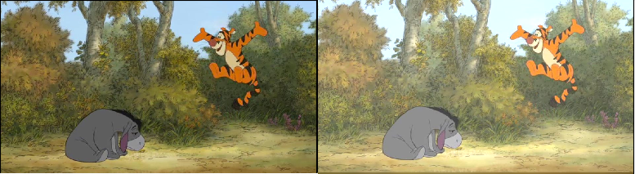

Figure: Original Image and Lighten Filter Result

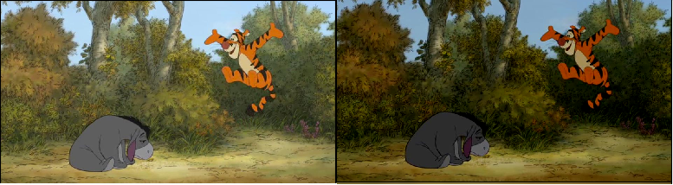

Figure: Original Image and Darken Filter Result

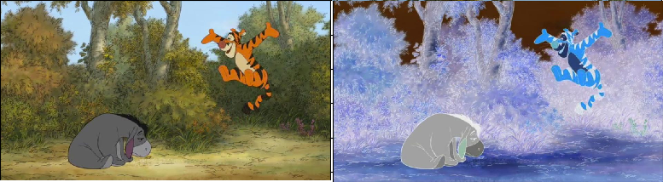

Figure: Original Image and Invert Filter Result

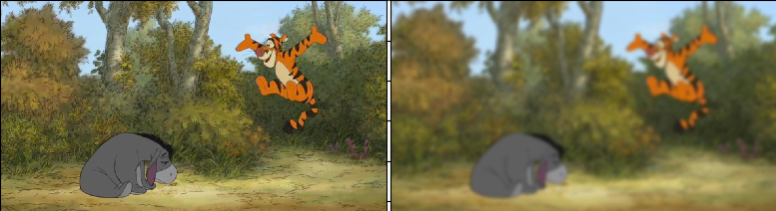Figure: Original Image and Gaussian Blur Filter Result

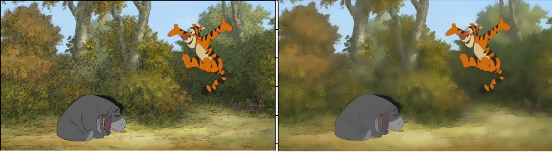

Figure: Original Image and Bilateral Filter Result

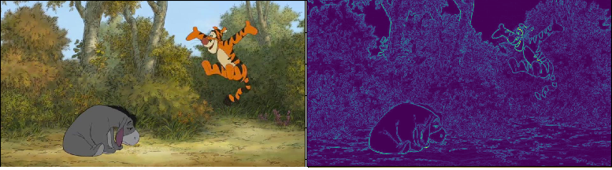

Figure: Original İmage and Find Edges Filter Result

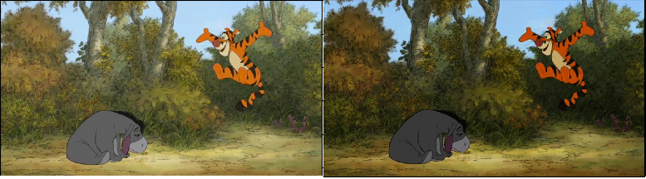

Figure: Original Image and Intensity Filter Result

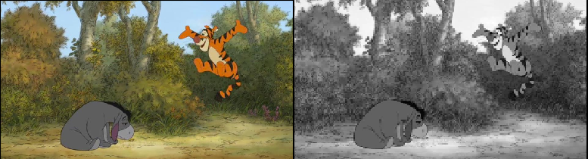

Figure: Original Image and Rescaling Result

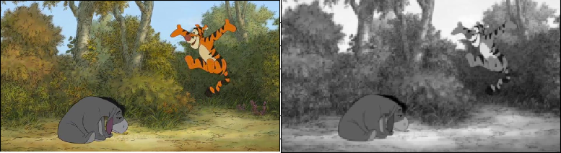

Figure: Original Image and Resizing Result

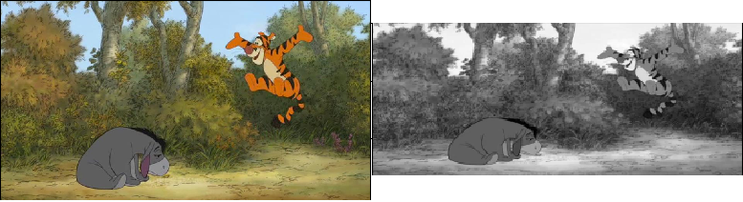

Figure: Original Image and Downscaling Result

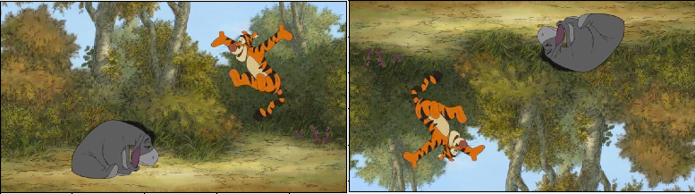

Figure: Original Image and Rotating Result

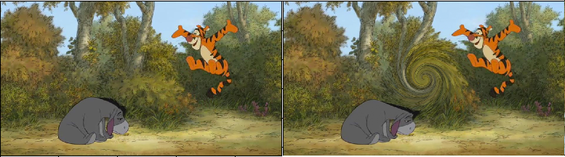

Figure: Original Image and Swirling Result

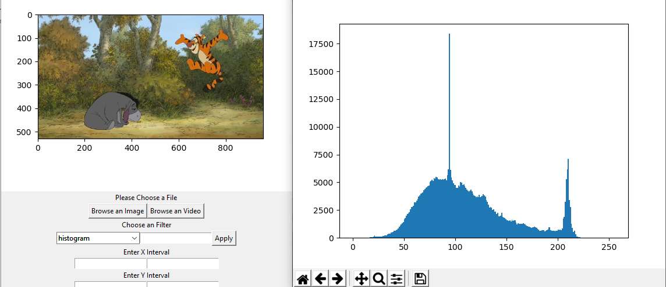

Figure: Plotting Histogram of Image

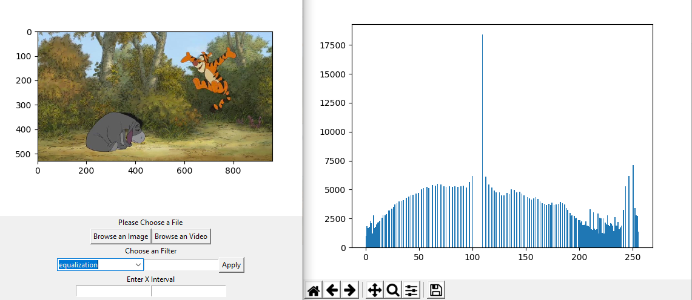

Figure: Plotting Histogram Equalization of Image



Figure: Original Image and Erosion Filter Result



Figure: Original Image and Dilation Filter Result



Figure: Original Image and Opening Filter Result



Figure: Original Image and Closing Filter Result

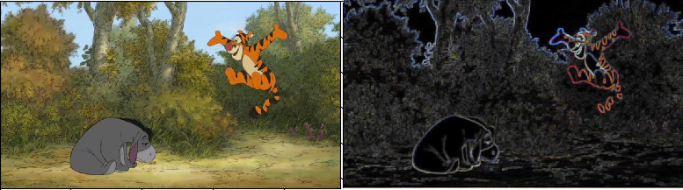

Figure: Original Image and Gradient Filter Result

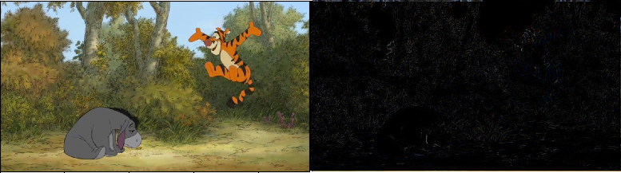

Figure: Original Image and Top Hat Filter Result

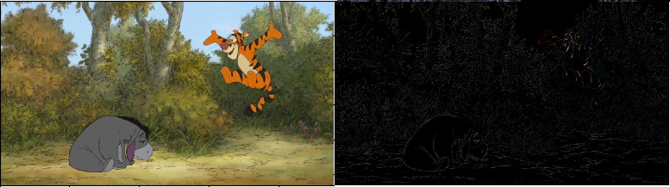

Figure: Original Image and Black Hat Filtering